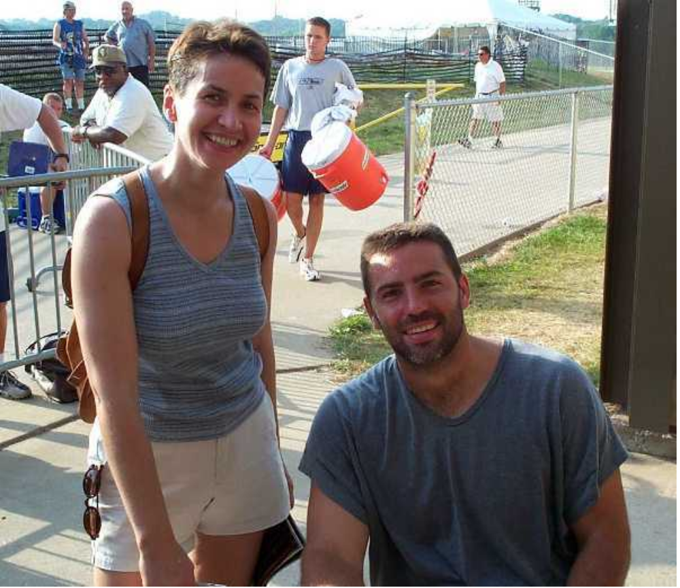

My wife Ursula with Kurt Warner

